In this post We’ll introduce a simple investing strategy that is well diversified and has been shown to work across different markets. In short, buying cheap and uptrending stocks has historically led to notably higher returns. The strategy is a combination of these two different investment styles, value and momentum. In a [previous post](https://databasedinvesting.blogspot.com/2019/06/the-most-important-chart-for-long-term.html) We explained how the range of possible outcomes in investing into a single market is excessively high. Therefore, global diversification is the key to assure that you achieve your investment objective. This strategy is diversified across strategies, markets and different stocks. The benefits of this strategy are the low implementation costs, a high diversification level, higher expected returns and lower drawdowns.

We’ll use data from [Barclays](http://shiller.barclays.com/SM/12/en/indices/static/historic-ratios.app) for the CAPEs which represent valuations, and Yahoo Finance using [quantmod](https://cran.r-project.org/web/packages/quantmod/index.html) for the returns that do not include dividends, which we’ll use as absolute momentum. Let’s take a look at the paths of valuation and momentum for the U.S. stock market for the last seven years:

[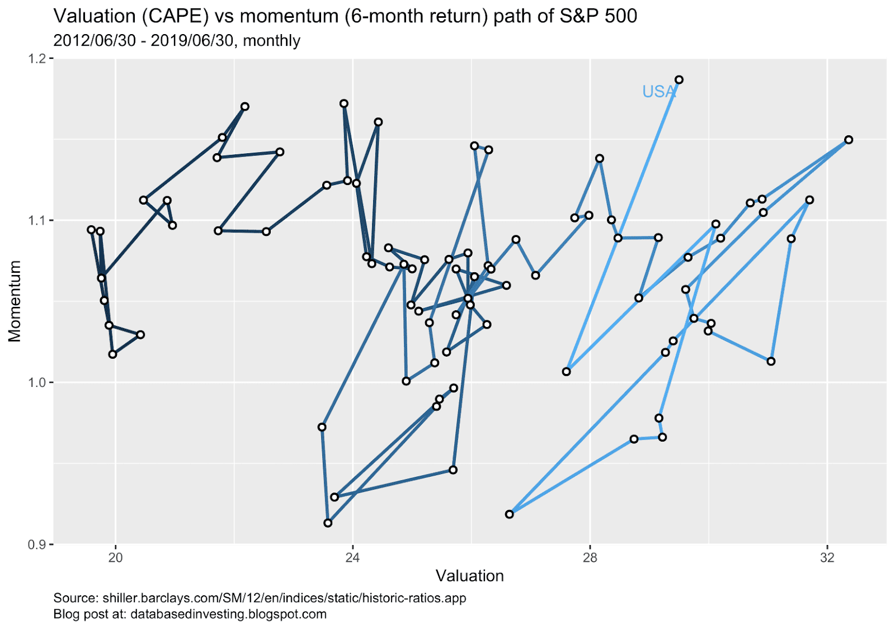](https://i1.wp.com/1.bp.blogspot.com/-_yRVxMLjXS0/XS4rHOtV7gI/AAAAAAAAAHw/-NmEgZGqX-Qjr4XefV6JuJRUz7qKG-PPwCLcBGAs/s1600/just_usa.png?ssl=1)

The two corrections are easy to spot, because momentum was low, and valuations decreased. The U.S. stock market currently has a strong momentum as measured by six-month absolute return, but the valuation level is really high. Therefore the U.S. is not the optimal country to invest in. So, which market is the optimal place to be? Let’s look at just the current values of different markets:

[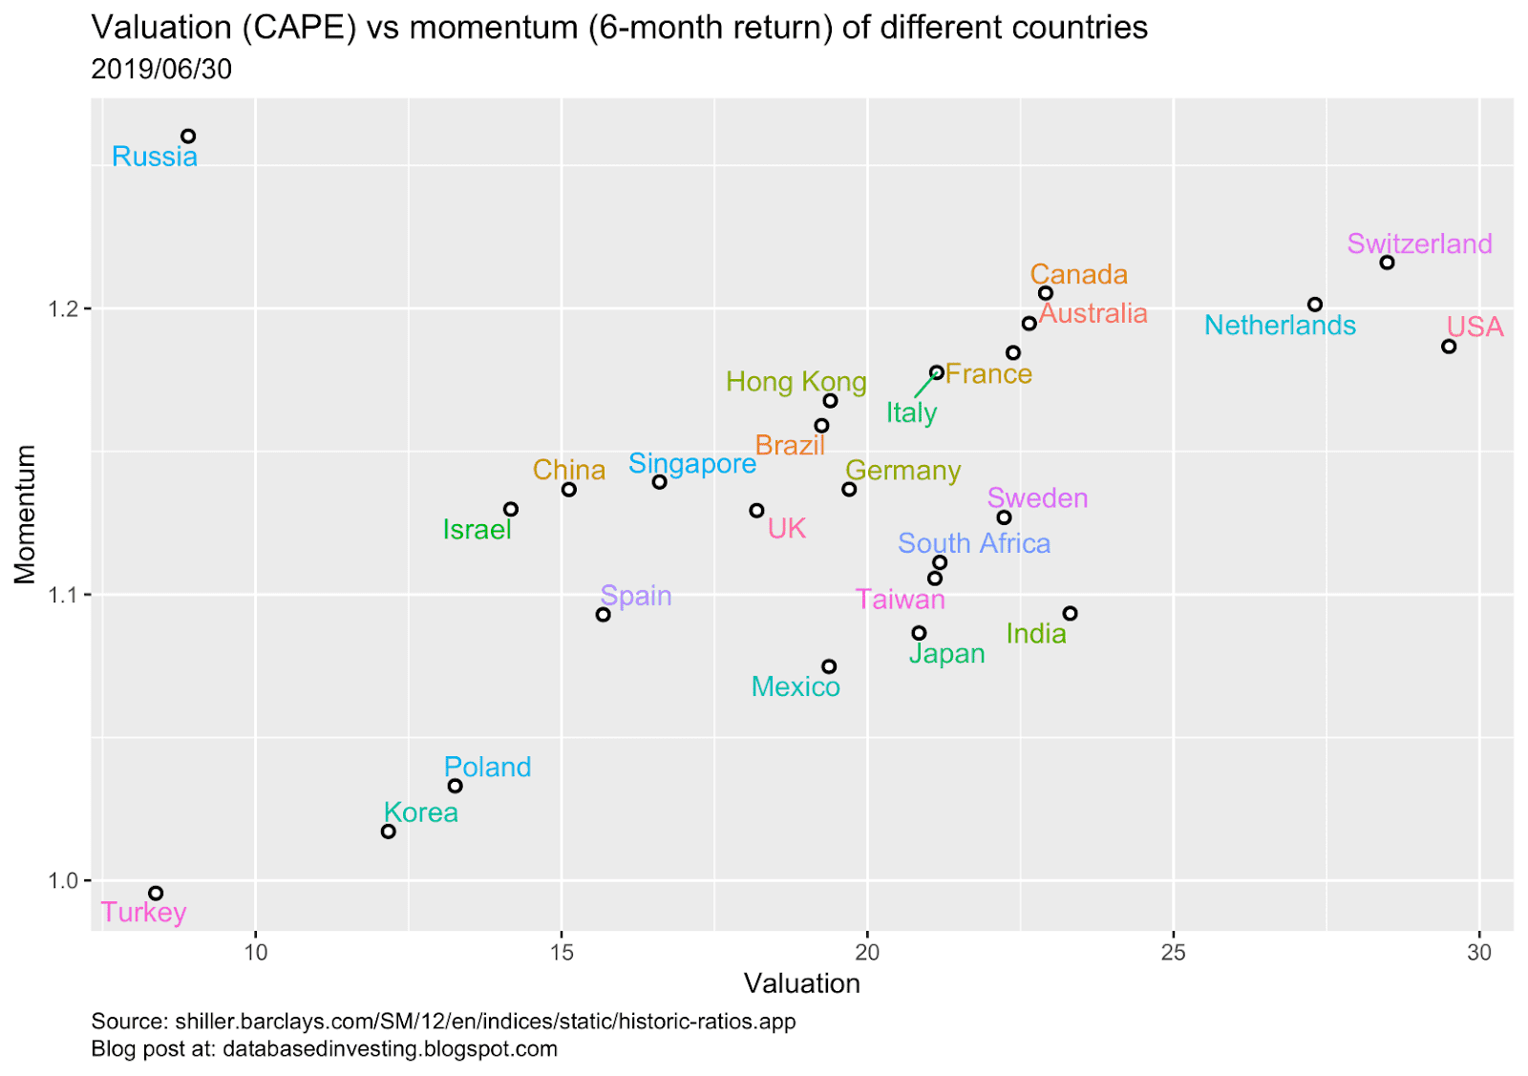](https://i0.wp.com/1.bp.blogspot.com/-TpvExXa5His/XS4quUixPFI/AAAAAAAAAHo/CwSJIRsJNjIgVTCHBJQCIYxJ6jPRzB9bgCLcBGAs/s1600/all_countries.png?ssl=1)

There is only one market that is just in the right spot: Russia. It has the highest momentum and second lowest valuation of all the countries in this sample. In emerging markets things happen faster and more intensively, which leads to more opportunities and makes investing in them more interesting. Different markets also tend to be in different cycles, which makes this combination strategy even more attractive. Let’s discuss more about these strategies and why they work well together.

**Research on the topic**

Value and momentum factors are negatively correlated, which means that when the other one has low returns, the other one’s returns tend to be higher. Both have been found to lead to excess returns and are two of the most researched so-called anomalies. Both strategies have been tried to be explained using risk-based and behavioral factors, but no single explanation has been agreed on for either of the strategies. The fact that there are multiple explanations for the superior performance can rather be viewed as a good thing for the strategies.

In their book “Your Complete Guide to Factor-Based Investing”, Berkin and Swedroe found out that the yearly returns of the two anomalies using a long-short strategy was 4.8 percent for value and 9.6 percent for the momentum anomaly. This corresponds to the return of the factor itself and can directly be compared to the market beta factor, which has had a historical annual return of 8.3 percent during the same period. This means that investing just in the momentum factor and therefore hedging against the market would have led to a higher return than just investing in the market. It is important to notice that investing normally just using a momentum strategy without shorting gives exposure to both of the market beta and momentum factors, which leads to a higher return than investing just into either of these factors.

Andreu et al. examined momentum on the country level and found out that the return of the momentum factor has been about 6 percent per annum for a holding period of six months. For a holding period of twelve months, the return was cut in half ([source](https://papers.ssrn.com/sol3/papers.cfm?abstract_id=1150972)). It seems that a short holding period seems to work best for this momentum strategy. They researched investing in a single country and three countries at a time and shorting the same amount of countries at a time. The smaller amount of countries led to higher returns, but no risk measures were presented in the study. As a short-term strategy I’d suggest equal weighting some of the countries with high momentum and low valuation. I’ve also tested the combination of value and momentum in the U.S. stock market, and it seems that momentum does not affect the returns at all on longer periods of time.

Value on the other hand tends to correlate strongly with future returns only on much longer periods, and on shorter periods the correlation is close to zero as I demonstrated in [a previous post](https://databasedinvesting.blogspot.com/2019/01/correlation-analysis-of-cyclically.html). However, the short-term CAGR of the value strategy on the country level in the U.S. has still been rather impressive at 14.5 percent for a CAPE ratio of 5 to 10, as shown by Faber ([source](https://papers.ssrn.com/sol3/papers.cfm?abstract_id=2129474), figure 3A). I chose to show this specific valuation level, since currently countries such as Turkey and Russia are trading at these valuation levels ([source](https://www.starcapital.de/en/research/stock-market-valuation/)).

The 10-year cyclically adjusted price to earnings ratio that was discussed in the previous chapter, also known as CAPE, has been shown to be among the best variables for explaining the future returns of the stock market. It has a logarithmic relationship with future 10-15 year returns, and an r-squared as high as 0.49 across 17 country-level indices ([source](https://www.starcapital.de/fileadmin/user_upload/files/publikationen/Research_2016-01_Predicting_Stock_Market_Returns_Shiller_CAPE_Keimling.pdf), page 11). A lower CAPE has also lead to smaller maximum and average drawdowns ([source](https://www.starcapital.de/fileadmin/user_upload/files/publikationen/Research_2016-03_CAPE_Results_Drawdowns_Keimling.pdf)).

Faber has shown that investing in countries with a low CAPE has returned 14 percent annually since 1993, and the risk-adjusted return has also been really good ([source](https://mebfaber.com/2019/01/06/you-would-have-missed-961-in-gains-using-the-cape-ratio-and-thats-a-good-thing/)). The strategy, and value investing as a whole, has however underperformed for the last ten years or so ([source](https://www.starcapital.de/fileadmin/user_upload/files/publikationen/Kapitalmarktforschung/Research_2019-04_Value_Cycle_Keimling.pdf)). This is good news if you believe in mean reversion in the stock market.

The two strategies work well together on the stock level, as shown by Keimling ([source](https://www.starcapital.de/fileadmin/user_upload/files/publikationen/Research_2015-11_Combining_Value_with_Momentum_Keimling.pdf)). According to the study, the quintile with highest momentum has led to a yearly excess return of 2.7 percent, and the one with the lowest valuation has led to a yearly excess return of 3 percent globally. Choosing stocks with highest momentum and lowest valuations has over doubled the excess return to 7.6 percent. O’Shaughnessy has shown that the absolute return for a quintile with the highest momentum was 11.6 percent, and 11.8 percent for value. Combining the two lead to a return of 18.5 percent ([source](http://investorfieldguide.com/2014512two-ways-to-improve-the-momentum-strategy/)).

Lastly, let’s take a closer look at some selected countries and their paths:

[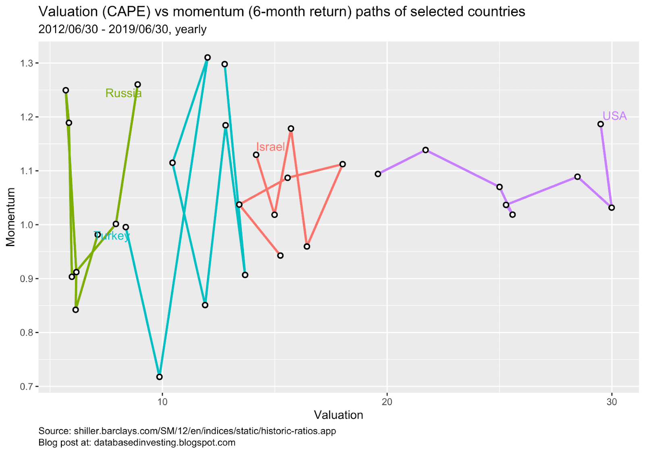](https://i2.wp.com/1.bp.blogspot.com/-m-qgbwGlhjM/XS45CM8forI/AAAAAAAAAH8/qmEI1ZSKiM0VG6xOeeQg7E0hBOPvgeoHgCLcBGAs/s1600/selected_countries.png?ssl=1)

As expected, the returns of the emerging markets vary a lot compared to U.S. market. U.S. has performed extremely well, but the historical earnings haven’t kept up with the prices. Israel on the other hand has gotten cheaper while the momentum has been good. Even though the momentum of U.S. is higher than any other point in time in this sample, Russia’s momentum currently is, and Turkey’s momentum has been way higher. Both Russia’s and Turkey’s valuations are less than a third of U.S. valuations, which makes these markets very interesting.

In conclusion, combining value and momentum investing into a medium-term strategy is likely to lead to excess returns as shown by previous research. The strategy can be easily implemented using country-specific exchange traded funds, and the data is easily available. Currently only Russia is in the sweet spot for this strategy, and Turkey might be once it gains some momentum. Investing to just one country is however risky, and I suggest diversifying between the markets with high momentum and low valuations.

Be sure to follow me on [Twitter](https://twitter.com/BasedInvestor) for updates about new blog posts!

The R code used in the analysis can be found [here](https://github.com/KaroRonty/MomentumAndValuation).